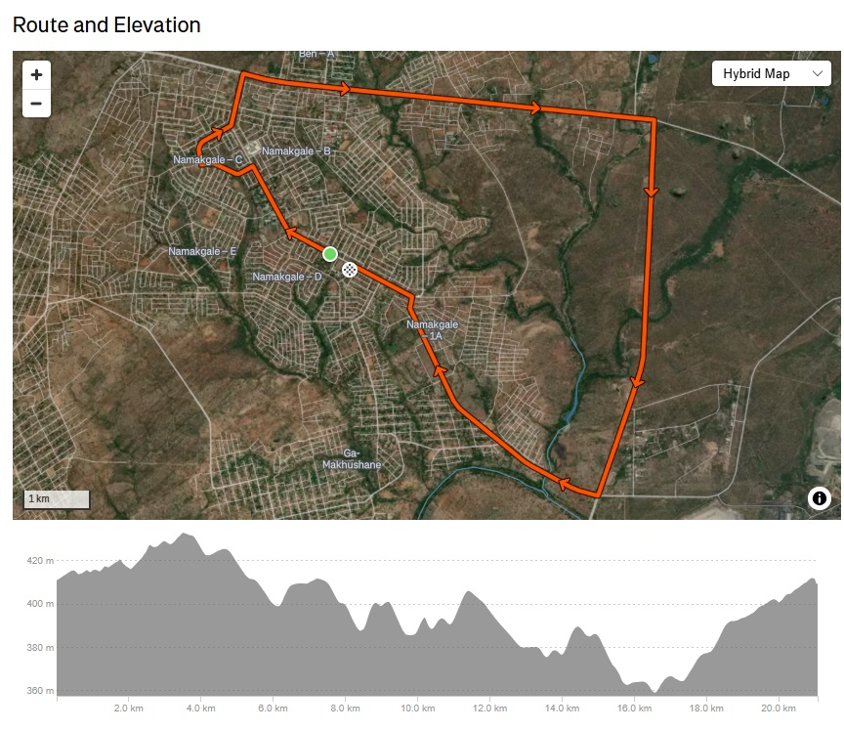

ROUTE DESCRIPTION F-21 HALF-MARATHON NAMAKGALE

- At the Foskor Community Centre signboard on Calvin Ngobeni Drive. (Dummy start 10m (E) of the actual start line.) Run NW along Calvin Ngobeni Drive. Road bears N at 0.8km.
- Just before Zakes Ngwasheng Drive opposite College. Continue N along Calvin Ngobeni Drive. Turn left (W) at Mavis Malatjie Street. Sign Missing
- By house 386 before bend. Turn right at T-junction into Phumolong Avenue. Bears right (E).
- On bend by bus-stop 30m before the (derelict) Lerato Bar. Turn left (N) into Calvin Ngobeni Road again. (WATERPOINT 1)
- 50m before cattle grid by “60” sign. Turn right (E) into National Road (R71) to Phalaborwa.

- By new “Bollanotto” buildings on right. Continue E on R71.

- 80m past Maputha Malatji turnoff by sign. Continue E on R71. (WATERPOINT 2)

- About 250m before Cellphone tower on right opposite ZWIDE walled property on left. Continue E on R71.
- Opposite ROCK VIEWER sign. Continue E on R71.
- By Marula trees before culvert. Continue E on R71. (WATERPOINT 3)
- 20m before Lulekani turn off before Lydenburg road (R530). Turn right (S) onto R40.

- Near new 36.2km signpost opposite kopje. Continue S on R40.

- Near new 35.2km signpost. Continue S on R40. (WATERPOINT 4)

- Near new 34.2km signpost. Continue S on R40.

- Near small tree opposite before culvert. 33Km signpost missing Continue S on R40.

- By old 32km signpost. (WATERPOINT 5) Turn right (W) towards Namagale at crossroads. (Makhushani Drive).
- About 100m after intersection. Continue towards Namakgale.

- After crossing bridge start running uphill. Km mark by Marula tree on right. Continue towards Namakgale.
- About 30m before banner structure across road opposite “castle” house. (WATERPOINT 6) Continue towards Namakgale. Road bears right.
- By middle of open un-used field near electricity pole NMA 25/9 on right. Continue towards Namakgale. (WATERPOINT 7 at about 19.5Km)
- 5m before the intersection, before stop sign. Turn left (NW) towards Central Namakgale into Calvin Ngobeni Drive at intersection with Makhushani Drive.
- By Stop sign at intersection (Madiba Street) by Foskor Community Centre, 30m before gate peg.
21.1 70m from the gate peg on the field.

